15. Mohr’s Circle for Stress or Finite Strain

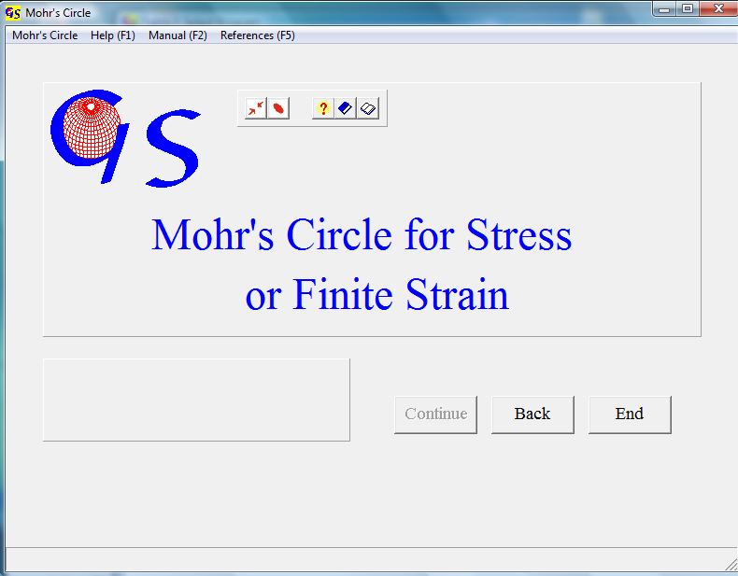
Fig. 1

This program (Fig. 1) can be used for the calculation of stresses or for the calculation of finite strain.
1.) Stress: Normal stress and shear stress in the plane are calculated from two principal stresses (σ₁ > σ₂) and from the angle Θ between the direction of the larger principal stress and a normal to a plane (Fig. 2). The stresses are shown on Mohr’s circle.
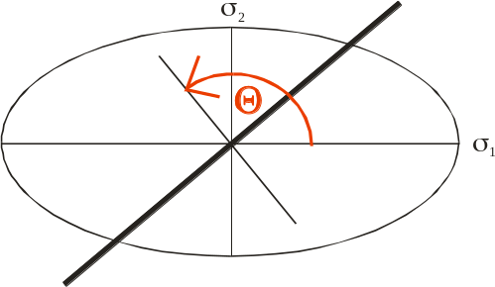Fig. 2

2.) Finite strain: Elongation and shear strain in a certain direction are calculated from the ratios of the long and short axes of a strain ellipse and the angle Θ‘ between the longer axes and this direction. A Mohr’s circle is drawn with the reciprocal values of the quadratic elongations (1/λ₁ < 1/λ₂).

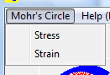
Fig. 3

Fig. 3 shows the menu for the choice of the method. When you click on either ‘Stress’ or ‘Strain the button “Continue” becomes active. Clicking on this button brings you to the form for calculation and plotting of the Mohr’s circle. Fig. 4 shows this form for calculation of stress after clicking the button “Start“.

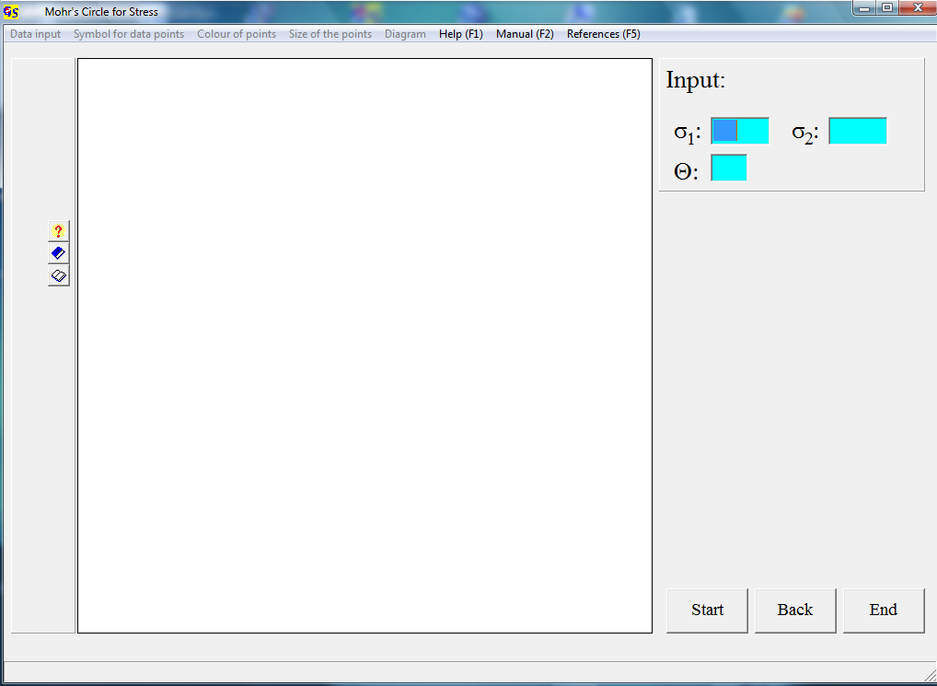
Fig. 4

σ₁ and σ₂ are integer values. Θ is counted anticlockwise from σ1.
Each input in the three fields must be terminated with “Return“. After this input the button “OK“ appears (Fig. 5).

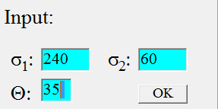
Fig. 5

Clicking on “OK“ produces a Mohr’s circle. Fig. 6 shows the diagram for positive principal stresses and a positive angle Θ. σ_{n} und σ_{s} are listed on the panel to the right of the diagram.

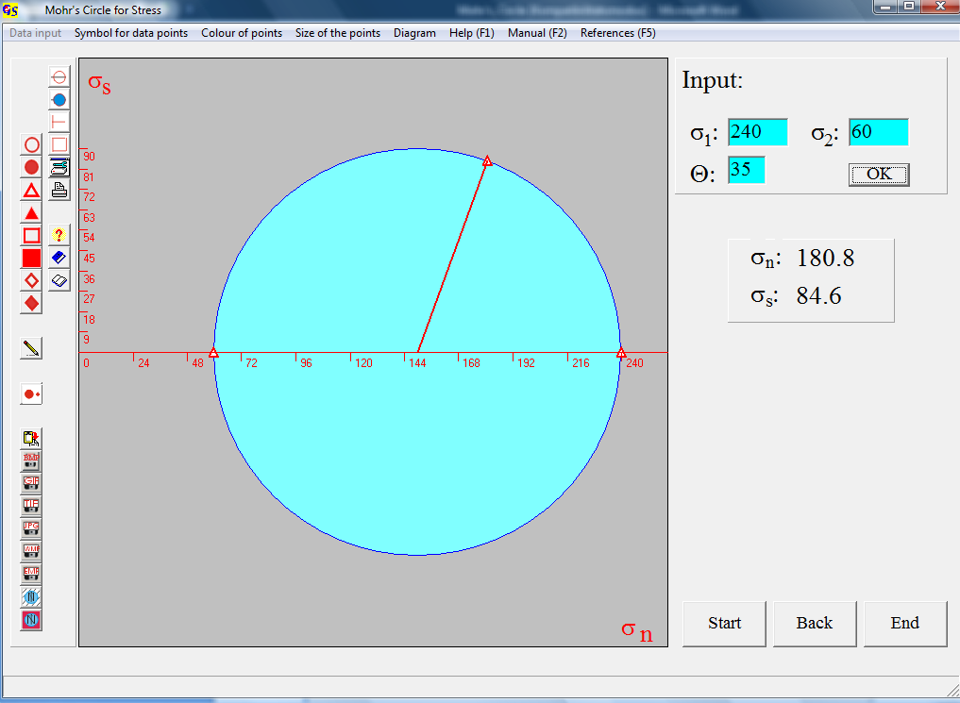
Fig. 6

σ_{n} and σ_{s} are calculated as follows:

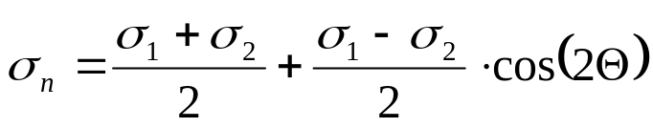,

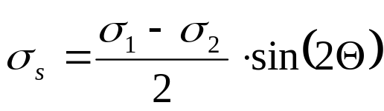

The symbols for the points and their colour and size can be changed in the pull-down menus. The menu „Diagram“ is the same as in all other graphic forms. Scaling of the coordinates is done in tenths of σ₁ and tenths or fifths of (σ₁ - σ₂)/2.
Fig. 7 shows the Mohr’s circle for σ₂ < 0 and Θ < 0.

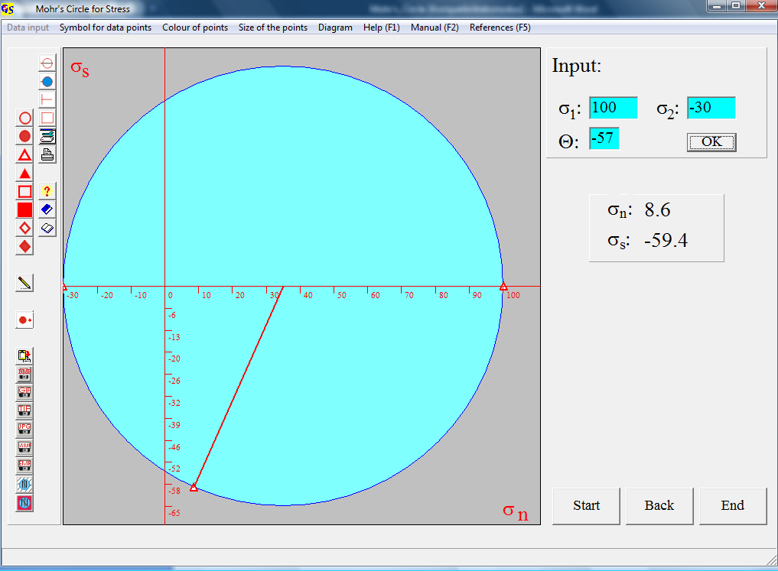
Fig. 7

Fig.7 shows the form for finite strain afer clicking the button “Start“. First the type of input data must be declared (Fig. 9). Two different types are possible:
1) Input can consist of the long and short axes of a strain ellipse (i.e. axes of a deformed former circular marker (ooid), s. Fig. 10).
2) Direct input of the elongations (Fig. 11).
In case 1) e₁ and e₂ are calculated with the assumption that no volume change takes place.

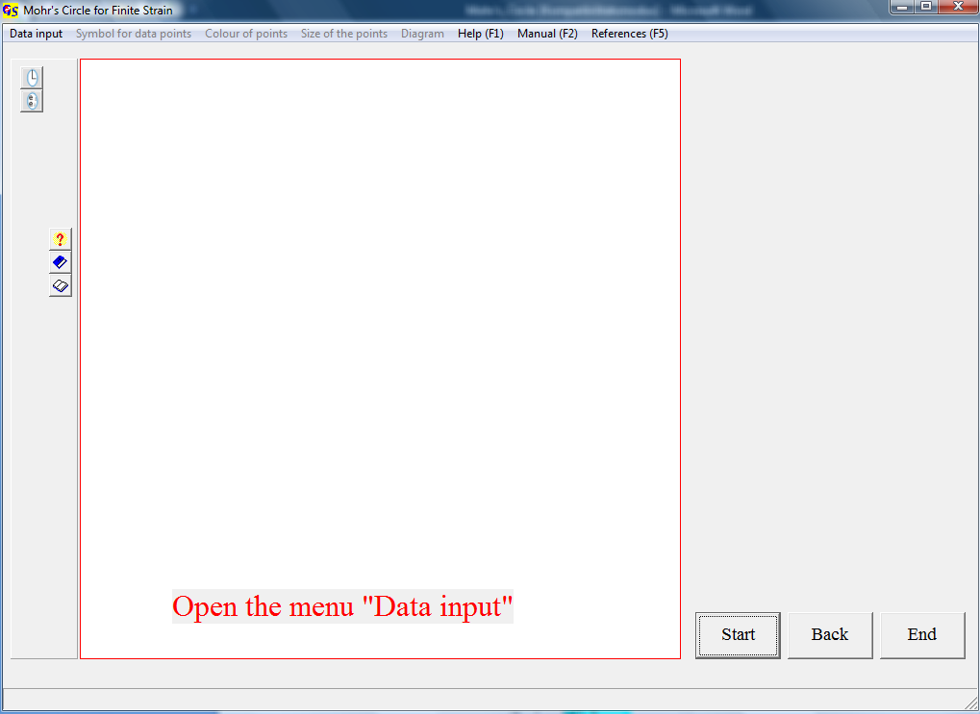
Fig. 8

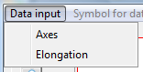
Fig. 9

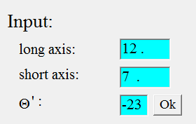
Fig. 10

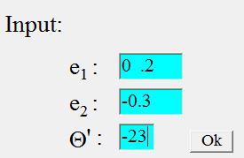
Fig. 11

All input must be terminated with “Return“. After input of the angle, in both cases the button “OK“ appears. Clicking on this button produces the diagram (Fig. 12).

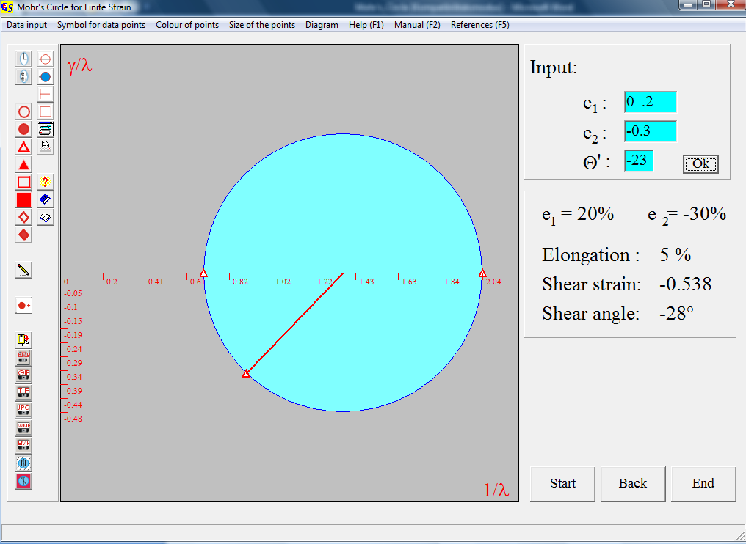
Fig. 12

Elongation and shear strain are calculated from the quadratic elongations:
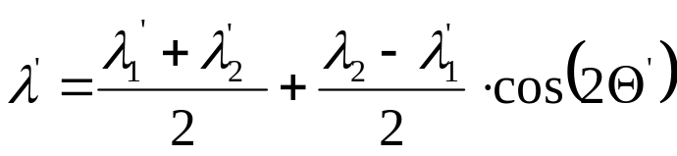
and
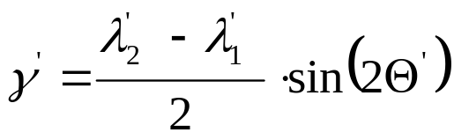,

with λ₁‘ = 1/λ₁,
λ₂‘ = 1/λ_{2,}
γ‘ = γ/λ .

